STAT 301 Homework 4 Name
- An obstetrician wanted to determine the impact that two experimental diets (A and B) and age of moms had on the birth weights of the infants. She randomly selected 18 pregnant mothers in the first trimester of whom 6 were 20 to 29 years old, 6 were 30 to 39 years old, and 6 were 40 or older. For each age group, she randomly assigned the mothers to one of the two diets. After delivery she measured the birth weights (in grams) of the babies and obtained the following data. Assume that the data follow the normal distribution.
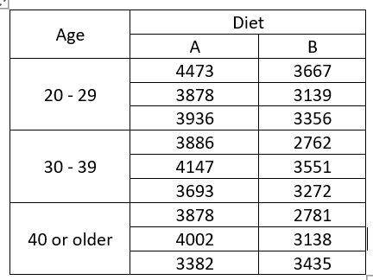
- What is the null and alternative hypothesis, in symbols, for testing the main effect of age?

- What is the test statistic and p-value for testing the main effect of age?

- What conclusion in the context can you draw based on the p-value in b)? (is there any significant mean weight difference between the three age groups?)

- What is the null and alternative hypothesis, in symbols, for testing the main effect of diet?

- What is the test statistic and p-value for testing the main effect of diet?

- What conclusion in the context can you draw based on the p-value in b)? (is there any significant mean weight difference between the A and B diet groups?)

- Is there a significant interaction between diet and age? List the p-value to explain.

- A researcher took 64 water samples from a stream running through a forest. The samples were collected over the course of a year. Each sample was analyzed for concentration of dissolved organic carbon (mg/L) in it. Each sample was categorized according to the type of water collected: groundwater from organic soil (Organic) or groundwater from mineral soil (Mineral), and categorized according to the location of the sample: the surface of the stream or the bottom of the stream.

The researchers wanted to determine if the mean concentration of dissolved organic carbon was the same between the two types of water collected, and between the two locations. The researchers want to know which type of water has the highest dissolved organic carbon. The data Soil testing is on D2L. Answer the following questions:
- What are the null and alternative of testing the mean difference between the two types of water?

- What is the test statistic and p-value for a)?

- What conclusion in the context from the p-value in a)?

- What are the null and alternative of testing the mean difference between the two locations?

- What is the test statistic and p-value for d)?

- What conclusion in the context from the p-value in d)?

- What is the test statistic and p-value for testing the interaction? What can you conclude from that p-value?

- Generate an interaction plot. Based on the plot, which type of water at which location reached the highest dissolved organic carbon?

- Researchers have sought to examine the effect of various types of music on agitation levels in patients who are in the early and middle stages of Alzheimer’s disease. Patients were selected to participate in the study based on their stage of Alzheimer’s disease. Three forms of music were tested: Easy listening, Mozart, and Piano Interludes. While listening to music, agitation levels were recorded for the patients with a high score indicating a higher level of agitation. Scores are recorded below. Use the data to answer the following questions:

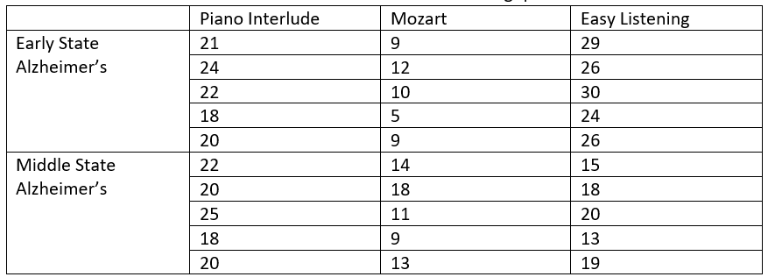
- What is the test statistic and p-value for testing the mean score difference between the early state Alzheimers and the middle state Alzheimers?

- What do you conclude in the context from the p-value in a)? (Is there any significant mean score difference between the two states?)

- What is the test statistic and p-value for testing the mean score difference between the three music types?

- What can you conclude from the p-value in c)? (Is there any significant mean score difference between the three types of music?)

- Is there a significant interaction between music type and the state of Alzheimer? List the p-value.

- If there is a significant interaction between the music type and the state of Alzheimer, separate the data based on the Alzheimer state and answer the following:

  - For the Early State Alzheimer’s, what is the test statistic and p-value to compare the mean scores from the three music types? What can you conclude from the p-value?

  - For the Middle State Alzheimer’s, what is the test statistic and p-value to compare the mean scores from the three music types? What can you conclude from that p-value?

- Use the “job and gender” data on d2l. Test the main effects of gender, main effects of job category and the interaction between job and gender. Note that this is an unbalanced design.
- Perform a two-way ANOVA to test the main effect of gender
- What is the test statistic and p-value for testing the main effect of gender?

- What do you conclude? Is there significant mean salary difference between male and female?

- Test the main effect of job category
- What is the test statistic and p-value for testing the main effect of job category?

- What do you conclude? Is there significant mean salary difference between the janitors, clerks, and managers?

- If there is a significant interaction, separate the data by job category and answer the following:
  - For the janitors, what is the test statistic and p-value for comparing the mean salary difference between males and females? Is there any significant difference between the average salary from male janitors and female janitors?

  - For the clerks, what is the test statistic and p-value for comparing the mean salary difference between males and females? Is there any significant difference between the average salary from male clerks and female clerks?

  - For the managers, what is the test statistic and p-value for comparing the mean salary difference between males and females? Is there any significant difference between the average salary from male managers and female managers?

